Name:曾熙茵、冯炜彦、廖思懿

Title : **Bluetooth** **Register**

Project Report

Date: 2023.6.3

Student ID:20213802035、20213802051、20213802055

**Bluetooth** **Register**

**1.** **Project** **Background**

In SCNU, it is an everyday routine to check whether the students attend classes timely and fully, for fear that some students will be absent from class deliberately. We want to find some program to make this routine more convenient. However, the current ways, such as the sign-in of some programs or uploading the cell phone location in WeChat, cannot guarantee the student wouldn’t leave class halfway and the students even could sign in at the dormitory, limited by the accuracy of positioning. So, to avoid this problem, we tried to develop an attendance checking software with a new checking mechanism, that is to check the attendance through Bluetooth communication.

In this software, teaching assistant can initiate check-ins and students can participate in check-ins. It can avoid the inconvenience of verbal check-in and solve the problems like inaccurate positioning.

**2.** **Project** **Design** **Concept**

To relief the work of development, we make some assumptions to simplify the real world situation, leaving this flaws to improve.

1. All students are in the Bluetooth range of monitor's phone.

2. Student are told to open our app to check-in before the class in the classroom by monitor.

3. To avoid the chaos of input the list of students to check, we only care about the name of students who have attend the check-in.

We design 3 screen to accomplish the work of check-in:

1. Register Screen: Student Register and Division. if you choose to be monitor, you will shift to monitor screen after click the register button. Otherwise, you will shift to student screen after input your name for check-in. Additionally, your choice and input will be record by the app.

2. Student Screen: Show the check-in Settings, the Start of auto check-ins and the Selection of monitor. The name, your name used for the check-in, the check-in procedure and monitor of this check-in are shown in the head of the screen. A button to select the monitor's device and another button to start the check-in.

3. Monitor Screen: Set the check-in settings, the Start of check-in 2 / 29

and the statistics of the name of the students has registered.

**3.** **Process** **discussion**

1.UI Design

1. 1 UI for Register Screen(activity_start_page.xml)

Design Window for StartPage UI

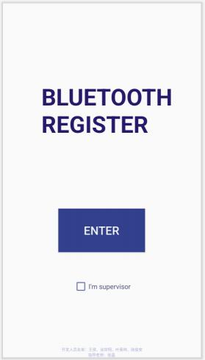

The home page consists of four parts, which are application information, entry button, identity options and team information. The function of the start page is to distinguish the identity of the check-in administrator and the participating students, and to guide them to the corresponding Activity page for check-in operation, so the function of the page is highlighted with larger buttons, and a larger position is reserved to make the software information more conspicuous.

Codes for StartPage UI

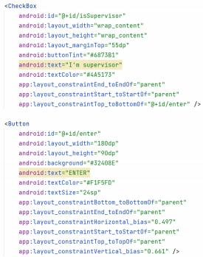

Main content are CheckBox and Button, others are textView.

1.2 UI for StudentActivity(student.xml)

Design Window for Student UI



The out-layer component is LinearLayout, inside layer is FrameLayout, a picture representing students is set to be the background.

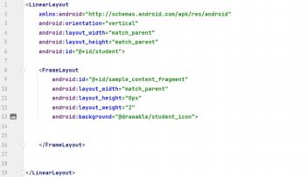

Codes for Student UI

Define a LinearLayou whose id is "student", containing a FrameLayout whose id is sample_content_fragment, set the background as “@drawable/student_icon” .

1.3 Manager UI

the design of the page of manager activity:

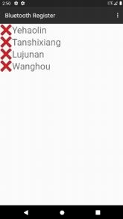

The four names are added by a function at the very beginning, and we add them to the list of students and display them on the page.

the UI code is only about a recycle view:

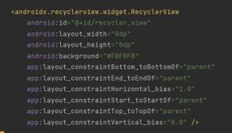

we set the four edges of the recycle view and the four edges of its parent to be overlapped.

1.4 Other UI components

(1) UI for Device List (activity_device_list.xml)

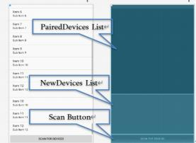

The Device List has two kinds, which is "PairedDevicesList" and "NewDevicesList". For the devices which have built bluetooth connections, their names will be added to PairerDevicesList, otherwise, to NewDevicesList. To scan and find devices, tap the button "SCAN FOR DEVICES", the scanned devices name then will be stored into according list.

Codes for DeviceList UI

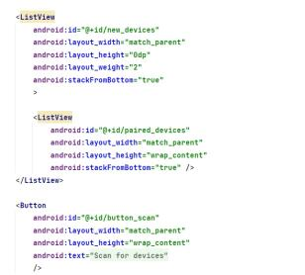

private CheckBox checkBox;

private SharedPreferences preferences;

private SharedPreferences.Editor editor;

The paired devices and newly-found devices are respectively defined as paired_devices and new_devices in type ListView. Scan

Button is defined as "button scan".

_

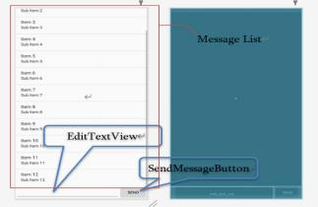

(2)UI Components for Bluetooth Chat ( fragment_bluetooth_chat.xml)

There are three parts in Bluetooth Chat Component, which is MessageList, EditTextView, SendMessageButton. Editing the text to be sent by bluetooth in EditTextView, tap SendMessageButton, the words will perfectly reveal at MessageList.

2、Activity Design

2. 1 MainActivity

(1)Overview

As a start page, different users are distinguished so that users

jump to the page corresponding to their identity properly.

Class Definition:

public class StartPageActivity extends Activity

Member variables:

private Button button;

Private Classes:

private class CheckListener implements CompoundButton.OnCheckedChangeListener

(2)Detailed Analysis

<1> In onCreate method

Set the click listener for the entry button. When clicked, we get the status of the identity checkbox to determine which Activity the intent should jump to, and call the corresponding overridePendingTransition method after startActivity according to the user's identity to achieve a different jump effect, making it easier for the user to notice and it makes it easier for the user to detect the wrong identity and perform the exit operation.

Part of the “anim” animation code used is as follows, which uses “translate” to translate the page, and uses the relevant parameters to

control the magnitude of the change and the duration of the change.

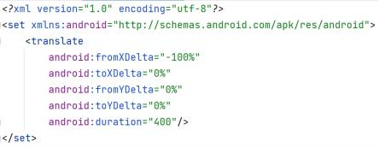

The listening for identity check-in is also set during the initialization of the Activity, and SharedPreferences is set and the previously reserved identity information is retrieved from it. Since there are more students who normally participate in check-in, the option of supervisor identity is not checked by default if the software is opened for the first time without the corresponding information.

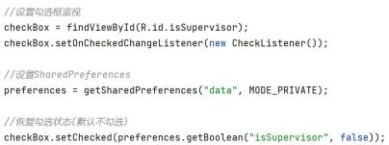

<2> In class CheckListener

The internal class implements the identity checkbox change listener. When the user checks the supervisor identity box, the corresponding prompt is made to prevent the user from touching it by mistake. Whenever the checkbox changes, the result is saved to SharedPreferences to ensure that the correct user information is saved when the page is opened next time.

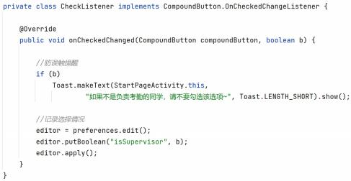

2.2 StudentActivity SampleActivityBase )

(public class StudentActivity

Override onCreate()

extends

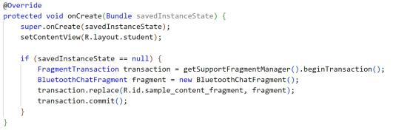

FragmentTransaction transaction can operate on the fragments ， using getSupportFragmentManager() to get targeted fragment. transaction.replace() will remove all the other fragments in the stack ， only the current fragment will be saved.

Add Menu

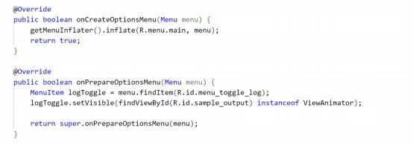

Run onCreateOptionsMenu()to create a new menu ， after that, this function will n longer be called. To view the menu and do some operations on it ， run onPrepareOptionsMenu().

2.3 ManagerActivity(public class ManageActivity extends Activity)

(1) global variables:

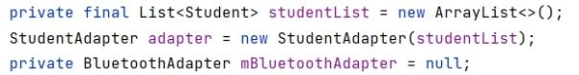

The list is used to display the student name and their sign_in situation, and the mBluetoothAdapter is used to get the information of the

bluetooth devices.

Student class:

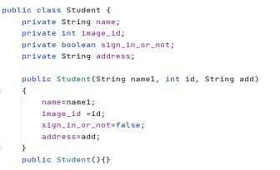

The class contains some basic information of students, and we first create four objects indicating the four members in our group.The image_id points to a picture of a cross or a tick, which shows whether the student has signed in or not.

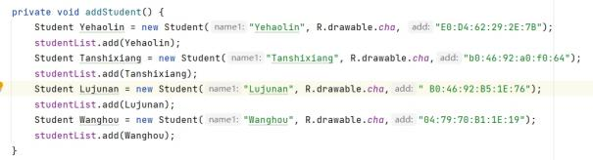

(2) Methods to realize signing in

First we define a function called find, which aims at finding the student object according to the address from the device we have connected to. At the beginning, we design the function find to finish this task.

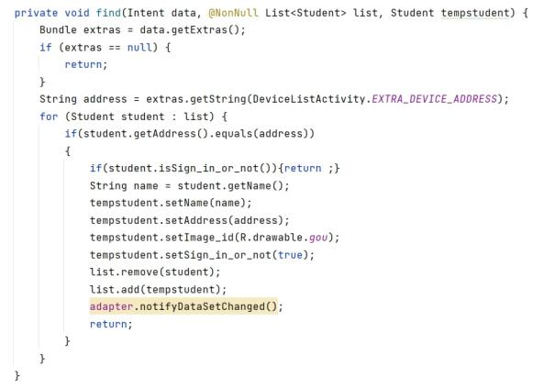

This function first create an empty student object, then it begins to go through the studentlist. When it finds the target, it will copy the information from it and give them to the empty one, next it will remove the origin one and add the new one at the bottom of the list, so that the manager can see the students who haven't signed in first. Also, when a student signs in, we turn his picture "cross" into a "tick".Finally we update the adapter to show the latest situation.

To get the address from the connected device, we use the same menu as the StudentActivity does, but we delete the chatting part. By calling the onActivityResult function, we can get the address we want from the DeviceActivity.

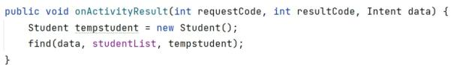

3、Bluetooth Communication Class Design

3. 1 BluetoothChatFragment.java

( 1)Overview

The BluetoothChatFragment class is a very important class for its usages of achieving the connecting between devices and its support to sending messages from one device to another. Often this class will call another class called DeviceListActivity, we will mention it soon.

The UI we may use in this class are made of two parts.

First let's see the UI of the menu:

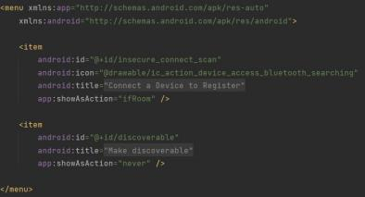

The two items are the choices from the menu, one with the text "Connect a Device to Register" and another one with the text "Make discoverable".

The next is the UI from the Bluetooth chat fragment:

fragment_bluetooth_chat:

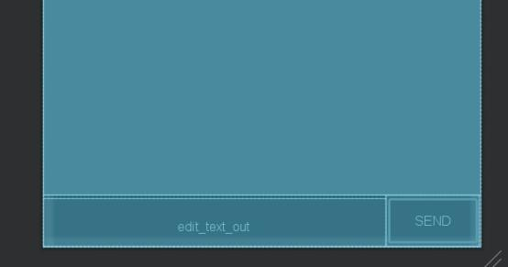

Class Definition:

public class BluetoothChatFragment extends Fragment Member variables:

private static final String *TAG* = "BluetoothChatFragment";

private static final int *REQUEST_CONNECT_DEVICE_SECURE* = 1;

private static final int *REQUEST_CONNECT_DEVICE_INSECURE* = 2;

private static final int *REQUEST_ENABLE_BT* = 3;

private ListView mConversationView;

private EditText mOutEditText;

private Button mSendButton;

private String mConnectedDeviceName = null;

private ArrayAdapter<String> mConversationArrayAdapter;

private StringBuffer mOutStringBuffer;

private BluetoothAdapter mBluetoothAdapter = null;

private BluetoothChatService mChatService = null;

Member functions:

private void setupChat() ;

private void ensureDiscoverable() ;

private void sendMessage(String message) ;

private TextView.OnEditorActionListener mWriteListener;

private void setStatus(int resId);

private void setStatus(CharSequence subTitle);

private final Handler mHandler;

public void onActivityResult(int requestCode, int resultCode,

Intent data);

private void connectDevice(Intent data, boolean secure);

(2)Detailed Analysis <1> The menu

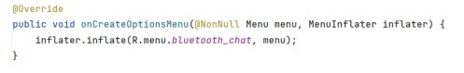

The code is used to import the menu UI to the activity, and the Onclick functions are as followed:

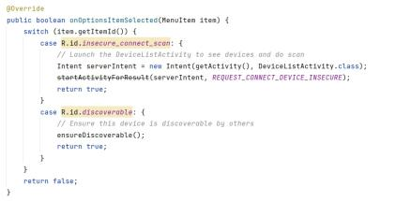

when clicking the first item in the menu, the activity will directly call the DeviceListActivity to "borrow" its usage of connecting devices, and when we click the second item, the system will ask if you want your device to be discovered by others.

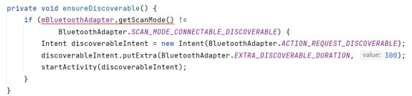

And it is realized by function "discoverable.putExtra", and the "value" filled in the brackets indicates the lasting time of the situation.

<2> The bluetooth chatting

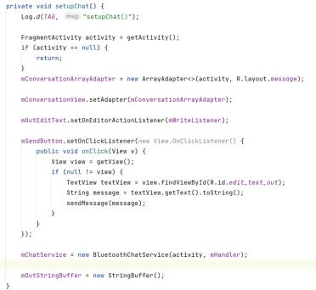

The setupChat function is the key to the bluetooth chatting between two devices. First we create a new adapter to store the messages so that we can see the chatting history on the screen, then we set this adapter to the mConversatiionView we already create before. The next is the sending button, we add an onclicklistener to it to turn the message in the textview into string variables and then send it out. Finally we initialize the bluetoothchatservice object and the Buffer.

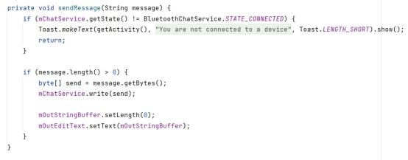

This is the sendMessage function, first we chaeck whether the device is in the connected situation, then we check if there is anything to

send by checking the length of message, if the answer is yes, we order the mChatService to write in the byte and send it. Finally we originate the outbuffer to initialize it.

<3> The handler

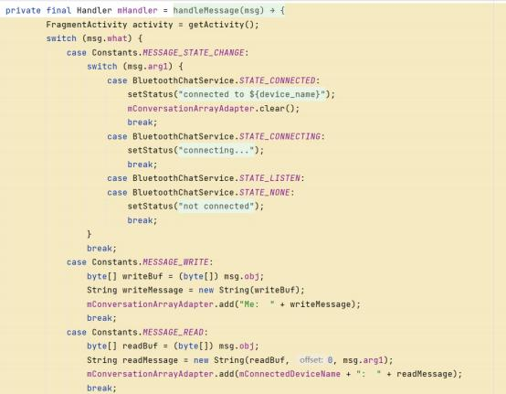

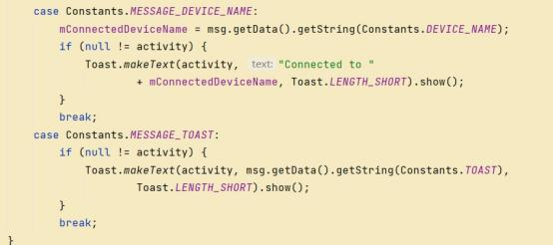

The handler is used to get the information back from the Bluetoothservice. We apply "switch" to determine the state of the msg.what, if the result is 1(Constant.Message_State_Changed), we need to judge the value of msg.arg1, according to the result, we need to apply different actions to update the status on the action bar. If the result

is MESSAGE_READ or MESSAGE_WRITE, we need to construct a string from the buffer, and if the result is MESSAGE_DEVICE_NAME or

MESSAGE_TOAST, we need to send a toast of different content.

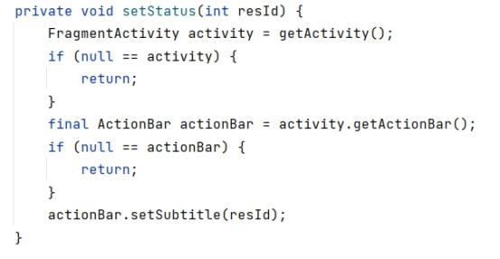

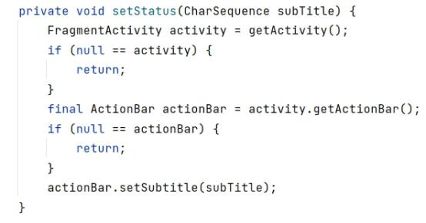

The setStatus function has two versions, they take in different arguments, but they are all used to update the status on the action bar.

<4> The onActivityResult function

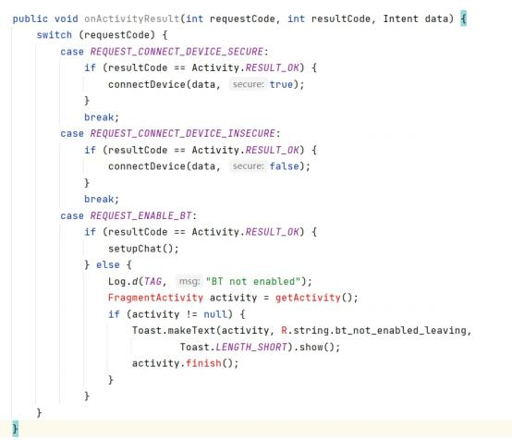

The function onActivityResult is used to return the data to the last activity. It takes in a unique requestcode from the function startActivityForResult, and the resultcode is return from the subactivity. When the subactivity returns a device to connect, we use function connect to connect the device; when it return a request to enable Bluetooth, if the Bluetooth is already enabled, we directly set up the chat; if it's not enabled, we send out a toast to tell the user that the Bluetooth is not enabled.

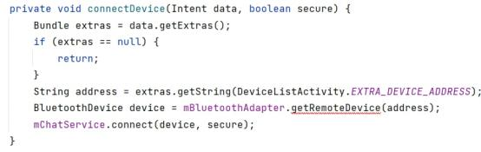

<5> The connectDevice function

Just like its name, this function is used to connect the device, it uses the getString function to get the bluetooth address of the device in the DeviceListActivity, finally it uses the mChatService to realize the connection.

3.2 Bluetooth Service (BluetoothChatService.java)

(1) Overview

This class does all the work for setting up and managing Bluetooth connections with other devices. It has a thread that listens for incoming connections, a thread for connecting with a device, and a thread for performing data transmissions when connected.

On the server side, use a BluetoothServerSocket to create a listening server socket. When a connection is accepted by the BluetoothServerSocket, it will return a new BluetoothSocket to manage the connection. On the client side, use a single BluetoothSocket to both initiate an outgoing connection and to manage the connection.

Class Definition：public class BluetoothChatService

Member variables

private static final String NAME = "Bluetooth

ChatInsecure";

private static final UUID MY_UUID =

UUID.fromString("8ce255c0-200a-11e0-ac64-

0800200c9a66");

private final BluetoothAdapter mAdapter;

private final Handler mHandler;

private AcceptThread mAcceptThread;

private ConnectThread mConnectThread;

private ConnectedThread mConnectedThread;

private int mState;

private int mNewState;

public static final int STATE_NONE = 0;

public static final int STATE_LISTEN = 1;

public static final int STATE_CONNECTING = 2;

19 / 29

public static final int STATE_CONNECTED = 3;

Member Functions：

public BluetoothChatService(Context context, Handler

handler)

private synchronized void updateUserInterfaceTitle()

public synchronized int getState()

public synchronized void start()

public synchronized void connect(BluetoothDevice device,

boolean secure)

public synchronized void connected(BluetoothSocket socket,

BluetoothDevice device, final String socketType)

public synchronized void stop()

public void write(byte[] out)

private void connectionFailed()

private void connectionLost()

Private Classes

private class AcceptThread extends Thread

private class ConnectThread extends Thread

private class ConnectedThread extends Thread

(2) Detail Analysis

<1> In class AcceptThread

This thread runs while listening for incoming connections. It behaves like a server-side client. It runs until a connection is accepted or until cancelled.

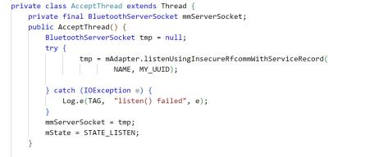

The most common type of Bluetooth socket is RFCOMM, which is the type supported by the Android APIs.To listen to a BluetoothSocket, use listenUsingInsecureRfcommWithServiceRecord() .

<2> In class ConnectThread extends Thread

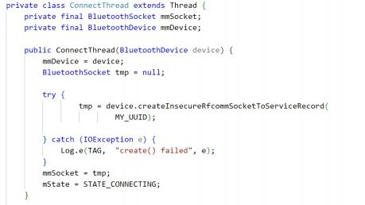

This thread runs while attempting to make an outgoing connection with a device. It runs straight through; the connection either succeeds or fails.

Get a BluetoothSocket for a connection with the given

BluetoothDevice.Set the state to STATE CONNECTING.

_

<3>In class ConnectedThread extends Thread

This thread runs during a connection with a remote device. It handles all incoming and outgoing transmissions.

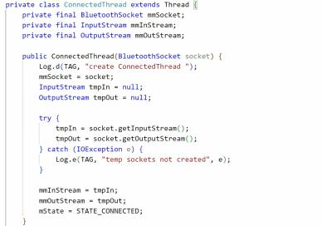

After connected, users can send messages. mmInstream and mmOutstream can obtain the input and output information.

Begin mConnectedThread

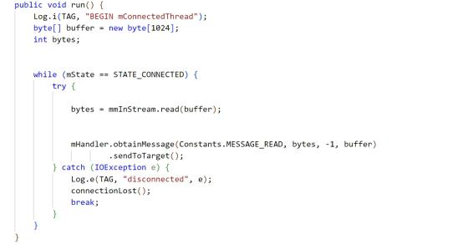

byte[] buffer is used to store the buffer reading from the input stream. Start a handler send the massage to the UI activity.

<4> Life cycle functions

Four functions are prepared for control the life of the chat service, which are start(), connect(), connected(), stop(). Their usages are shown in the following table.

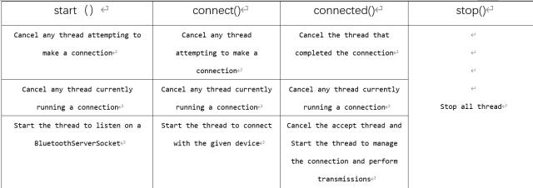

3.3 Device List (DeviceListActivity.java)

(1) Overview

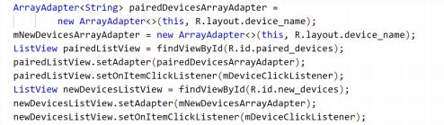

Reveal the new devices and paired devices scanned by bluetooth. Class Definition ： public class DeviceListActivity extends

Activity

Member Variables：

public static String EXTRA_DEVICE_ADDRESS =

"device address"

_

private BluetoothAdapter mBtAdapter

private ArrayAdapter<String> mNewDevicesArrayAdapter

Member Functions：

@Override

protected voidonCreate(BundlesavedInstanceState)

@Override

protected void onDestroy()；

private void doDiscovery() ；

Private Objectss：

private AdapterView.OnItemClickListener

mDeviceClickListener

private final BroadcastReceiver mReceiver

(2) Detail Analysis

Class DeviceListActivity is used for obtaining device information. Member variable BluetoothAdapter mBtAdapter is the basic object in Android bluetooth ， having the ability running bluetooth-concerned functions ， and ArrayAdapter<String> mNewDevicesArrayAdapter can save the name of new devices, then sending the data to UI interface.

<1> In protected void onCreate(Bundle savedInstanceState) Define pairedDevicesArrayAdapter and its UI components

Initializ pairedDevicesArrayAdapter and mNewDevicesArrayAdapter, choose ListView as the UI component, and initialize PairedListView, newDevicesListView. Set the listener for clicking.

Define the Receiver of Broadcast

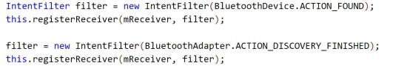

BluetoothDevice.ACTION FOUND is the constant value when a

_

device is found ，BluetoorhAdapter.ACTION_DISCOVERY_FINISHED is the constant value when the discovery is finished.

Get the current pairedDeviceList, add them to the Adapter

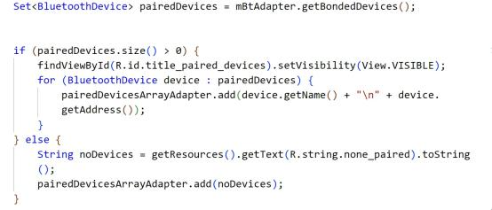

If pairedDevices.size() is greater than zero, that means there exists paired devices. Then add the device names and MAC address to Adapter, otherwise, reveal "no paired devices".

<2>In protected void onDestroy()

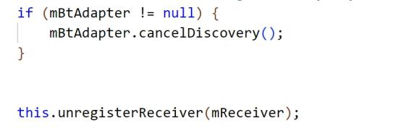

When the device list is closed, cancel the discovery and unregister the receiver.

<3> In private void doDiscovery()

Searching function, and reveal the result in UI interface

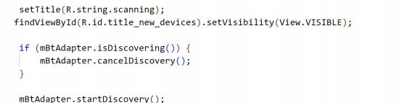

When the discovery is started, funtion setTitle() can reveal "scanning" to inform users. If new devices are found ( R.id.title_new_devices ) , their names will be put into device list and set visible.

<4>In private AdapterView.OnItemClickListener mDeviceClickListener Set ONItemClickListener()

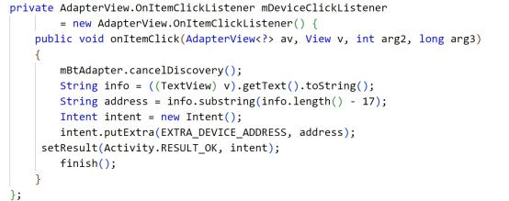

When the item in device list is clicked, cancelDiscover() will be called to stop discovering devices. String address saves the MAC address, which is the last 17 numbers of String info, that's why address =info.substring(info.length()-17). Finally, send intent containg MAC address to setResult().

<5>In private final BroadcastReceiver mReceiver

mReceiver listens to the states and update itself when states changes

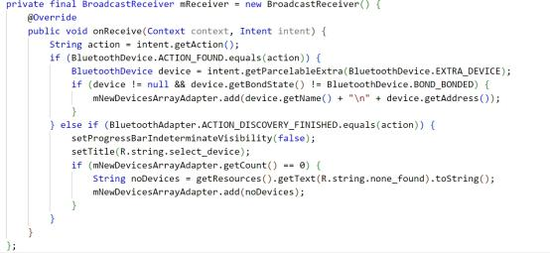

Override onReceive() ， call intent.getAction() to listen to the broadcast.

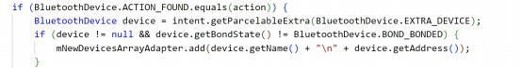

intent.getParcelableExtra() can put the object into Parcel Object, and restore it if necessary, thus implimenting passing objects between two activities. device.getBondedState() returns the state of the bond, when it is bonding, returns BOND_BONDGIND, when successfully bonded, reutnr BOND_BONDED, no device to be bonded, return BOND_NONE. When the devices has never been bonded, which means getBondState() != BOND_BONDED, add that device to mNewDevicesArrayAdapter.

Finish the Discovery

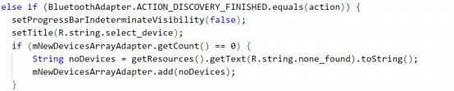

There are five constant values in Android bluetooth actions ，they

are ACTION _DISCOVERY _STARTED ， ACTION_ DISCOVERY_

FINISHED ，ACTION LOCAL NAME CHANGED ，ACTION SCAN

_ _ _ _ _

MODE CHANGED ， ACTION STATE CHANGED. When

_ _ _

BluetoothAdapter.ACTION_DISCOVERY_FINISHED.equals(action) is true ， bluetooth adapter finished its searching, and entitle the found



names.If there is no objects in the adapter，entitle “NO Device” .

**4.** **Result** **analysis**

4. 1 Work Flow on real phone <1> student

(1) Before check-in

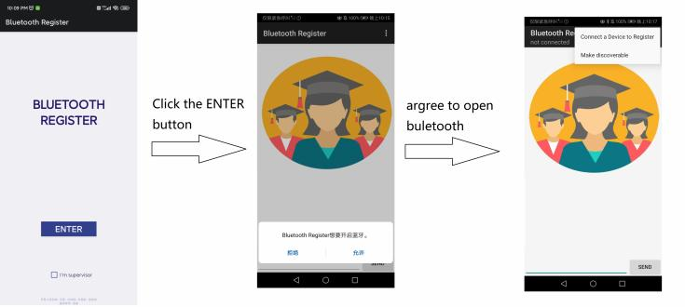

(2) Bluetooth chat between two student, type and send message

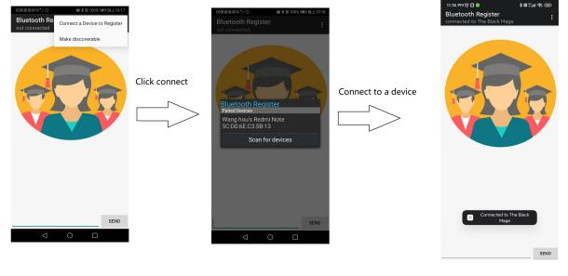

<2> Manage

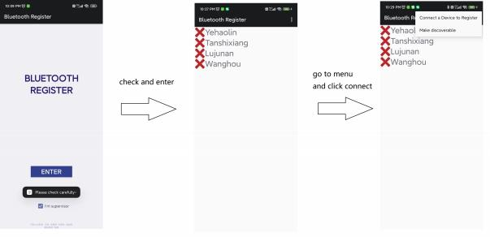

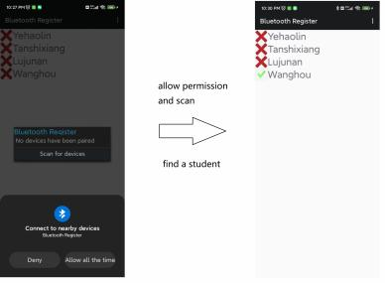

4.2 Conclusions & Inferences

Although, we finally accomplish using bluetooth to register. Apparently, our work is far from being sufficient, lack of optimization.

4.2.1 Drawbacks & To improve

We are determined to optimize our work in the following aspect.

1. Redundant function. We do not digest the official example of bluetooth chat, which was built years ago, so as to rebuild a effective bluetooth app.

2. Build in student list. In manager side, we find students by scan the surrounding device and compare with the id build in our app, which is impractical.

28 / 29

3. Insufficient info exhibition. The info provided to user is to less too construct a satisfying check-in.

1. **App testing**

We have selected various types of mobile phones on the cloud testing platform to test our software, and the interface for selecting the model is as follows.

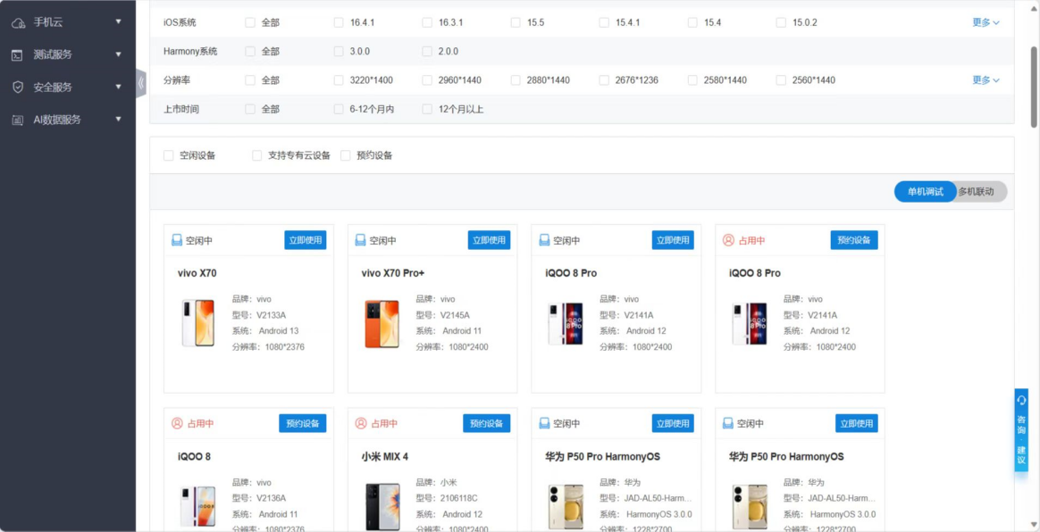

The interface for cloud real machine testing is shown in the figure, and we can directly test our mobile application by operating the cloud real machine.

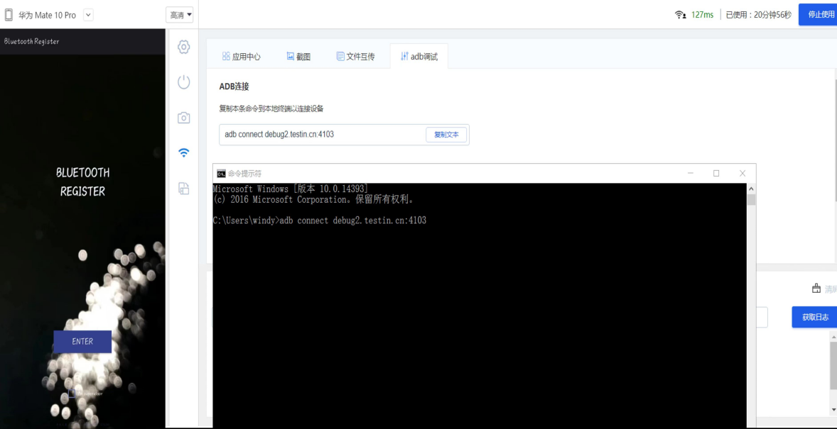

In compatibility testing, most models have passed the test, a small number of models have failed the test due to different reasons, and there are also some models that have failed the test due to platform reasons.

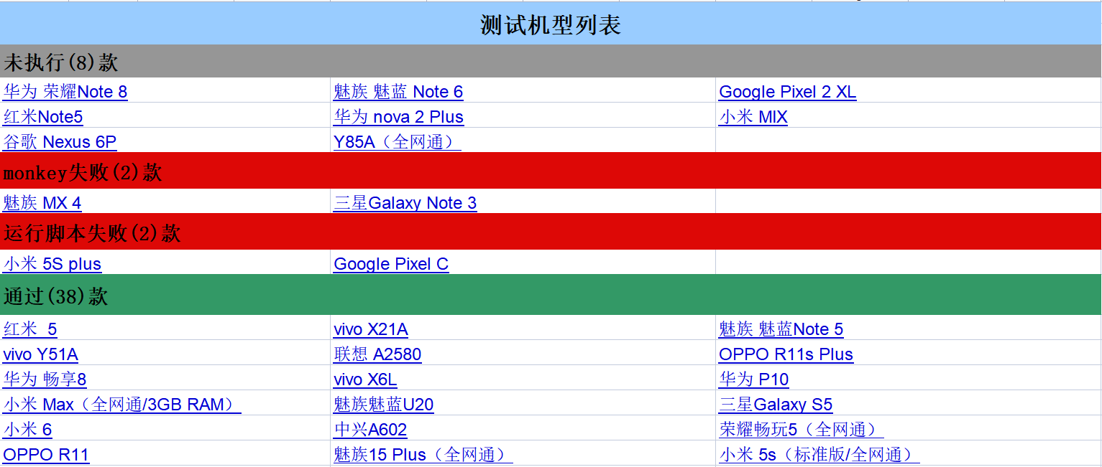

Here we will demonstrate the different failure reasons and their proportions for testing. It can be seen that the main failure reasons are monkey failure and running failure, while others have successfully run.

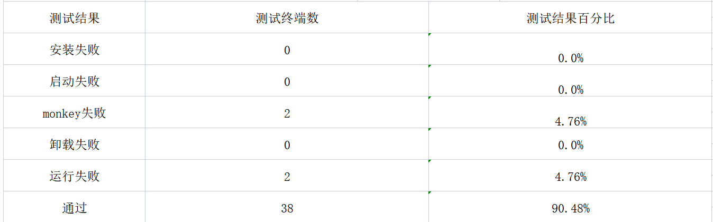

Through cloud real machine testing, compatibility testing, and functional testing without results display, we can see that the availability and practicality of this mobile software can meet practical requirements and can be delivered to relevant manufacturers for optimization and release.

1. **Feedback**

We chose these questions to do the questionaire.

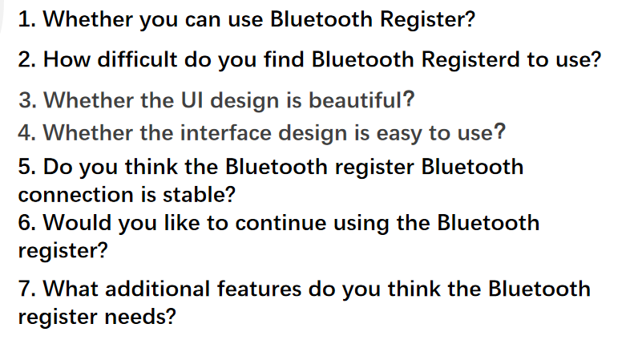

In whether the UI design is beautiful this question:

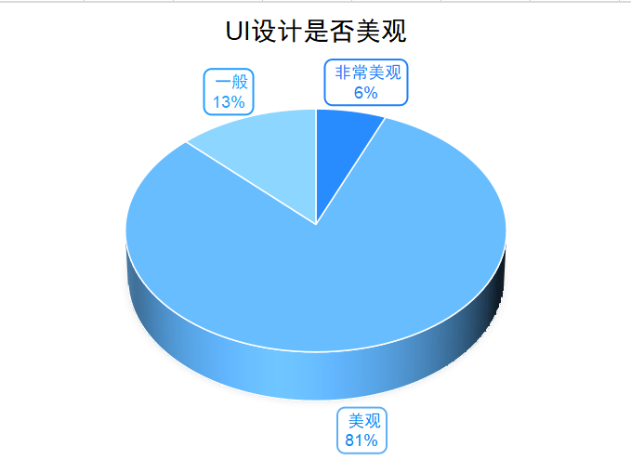

Most users think it is beautiful, a few users find it very beautiful and average.

Based on user feedback, we will further optimize the UI design to improve user satisfaction with the product.

In Whether the interface design is easy to use this question:

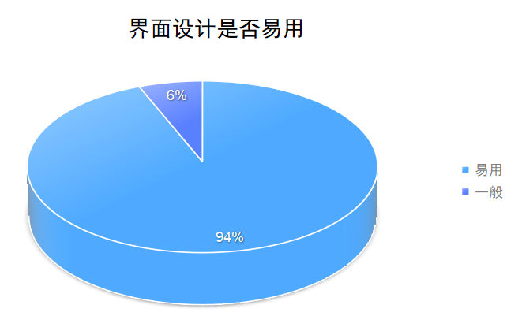

Most users find the Bluetooth Register easy to use, but a few find it average.

So we'll consider providing more detailed instructions and tutorials early on.

The other we can do is Optimize the stability of our software's Bluetooth connection, adding teacher edition and student edition can meet the needs of different users and the practicability of the software can be improved by adding the function of class schedule reminder and student check-in query.

1. **Conclusion**

We have completed most of the ideas for the app at the beginning of the semester, and our app is very good enough for users to connect to Bluetooth and continue to use it during the course. But this is not enough, maybe in the future we will implement the teacher count no-sign list, and class division and other features.

Through this course design, we have deeply realized the importance of teamwork. In a team, everyone has their own expertise and advantages, only by giving full play to everyone's advantages, in order to achieve the best results.